--Kailing Peng

--Alessia Vannini

**Non-profitable Children Charity**

There are different projects for children-in-need on support of donations. Children need to be at the age between 7 and 15 years old.

Registered children can join in as many projects at the same time to get the help they need. A new program proposal needs at least 3 interested applicants to be considered and evaluated. In case some needs are not covered by running projects, individual sponsorship by a sponsor is also possible.

The Operation team bookkeeps the finance, coordinates applications and registrations, organizes activities to inform sponsors of on-going project, and raise fund for future ones.

A sponsor can register himself anonymously or with personal details. To keep the amount tracked , all donations need to be made through either in cash at counter, by check or by bank transfer. The minimum amount of a single donation is CHF 10.

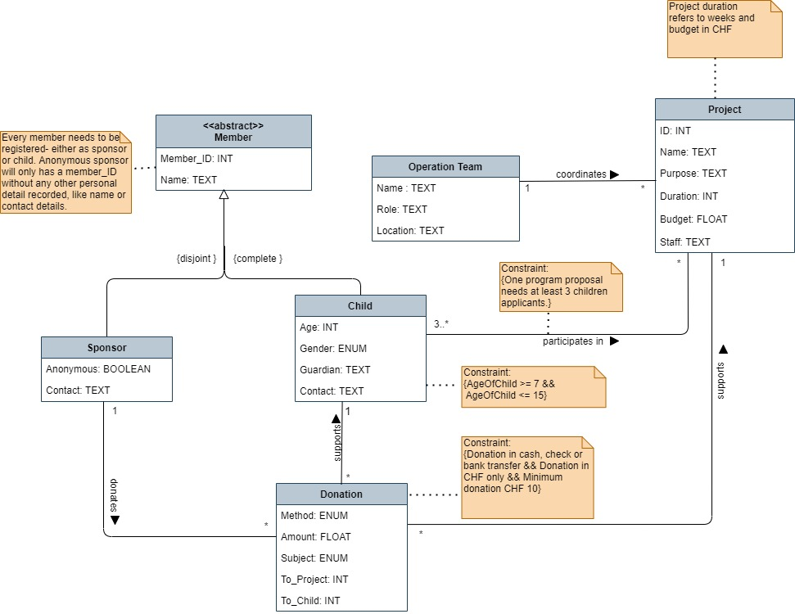

**Vererbung: Abbildungsregel 3b)**

- Die Vererbung ist {disjoint} somit kann Abbildungsregel 3b) gewählt werden

- Mit 3b) haben wir eine übersichtliche Lösung, die einfache Zugriffe auf Tabellen erlauben (Infos sind alle direkt in Tabelle enthalten)

- Es gibt wenig gemeinsame Attribute (ID, Name – wobei ID generiert) somit kann Semantikverlust in Kauf genommen werden

- Zwischen «child» und «sponsor» gibt es nur eine indirekte Assoziation über «donation» (die Primary Keys werden über serial generiert), somit sehen wir da kein Problem wegen Annomalien

- Da doch einige Attribute bei Subklassen vorhanden sind, wird nicht die Variante c) gewählt, da es viele NULL-Werte in der Superklasse gegeben hätte

**Relationales Modell in relationales Schreiweise**

team (

name VARCHAR (30) PRIMARY KEY,

role VARCHAR (20) NOT NULL,

location VARCHAR (40) NOT NULL

);

project(

id INTEGER PRIMARY KEY,

full_name VARCHAR (30) NOT NULL,

purpose VARCHAR (30),

duration INTEGER,

budget FLOAT NOT NULL,

*staff* VARCHAR (30) REFERENCES team

);

sponsor (

id INTEGER PRIMARY KEY,

name VARCHAR(30),

anonymous BOOLEAN NOT NULL,

contact VARCHAR(100)

);

child (

id INTEGER PRIMARY KEY,

name VARCHAR(30) NOT NULL,

age INTEGER NOT NULL,

gender ENUM('male', 'female', 'x') NOT NULL,

guardian VARCHAR(30) NOT NULL,

contact VARCHAR(20) NOT NULL

);

child_project (

*child_id* INTEGER NOT NULL REFERENCES child,

*project_id* INTEGER NOT NULL REFERENCES project

);

donation (

id INTEGER PRIMARY KEY,

method ENUM('cash', 'check', 'bank_transfer') NOT NULL,

amount FLOAT NOT NULL,

*sponsor* INTEGER NOT NULL REFERENCES sponsor,

donation_subject ENUM('child', 'project') NOT NULL,

*to_child* INTEGER REFERENCES child,

*to_project* INTEGER REFERENCES project,

);